**Exercises Text files**

**Exercise 1**

For this exercise you use the file *first_names.txt*.

1. Write a program that prints all first names **without** using a List.
2. Complete your program so that you print at the end:



1. 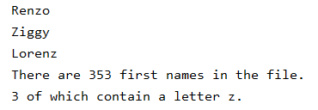Customize your program so that you only print the first names that contain a letter z. You'll get this result:

**Exercise 2**

Use the file *first names.txt* again.

Read the complete file and put all first names in a **List**. Print this list in reverse order.

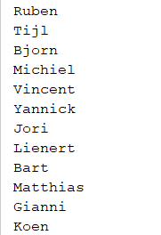

…

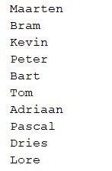

**Exercise 3**

Use the file *first_names.txt* again.

Read the complete file and put all the first names in a List. Print the names 10 by 10.

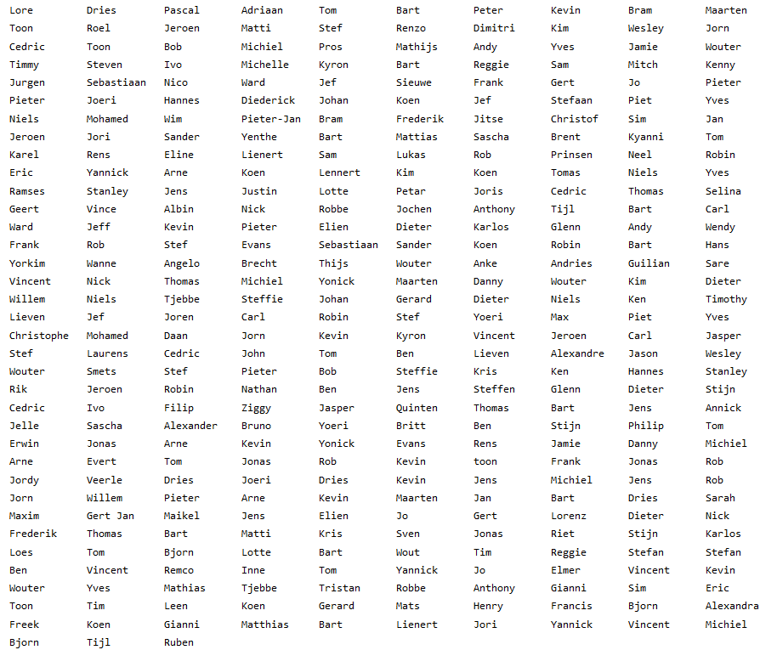

Tip: the *ljust(number)* method will left align the string, using a space as the fill character. By setting this number to 13, for example, you get 10 nicely aligned columns.

**Exercise 4**

For this exercise you use the file *irish_song.txt*.

Write a program that searches for the shortest line in the song:

**Exercise 5**

For this exercise you use the file *books.txt*.

The odd lines contain the titles of books, the even lines the corresponding author data. You may assume that the file contains an even number of lines.

Write a program that prints the contents of the file as follows:

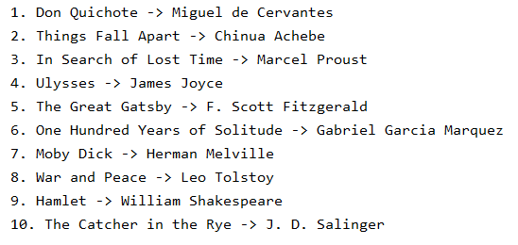

**Exercise 6**

For this exercise you use the files *wish1.txt, wish2.txt, wish3.txt*... *wish10.txt*.

Write a program that randomly determines which file will be printed. The printout can be this one, for example. Watch the title:

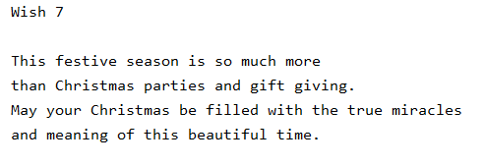

**Exercise 7**

For this exercise you use the file *playlist.txt.*

Write a program that displays the playlist in this way. Pay attention to the details!

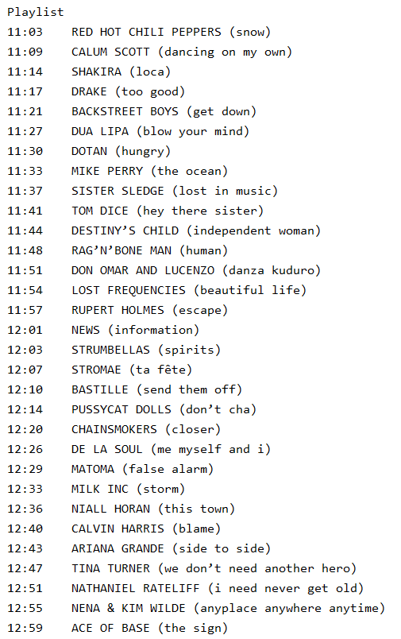

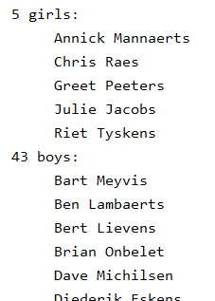**Exercise 8**

You have an alphabetically sorted *contacts.csv* file with the following information for each contact: surname; first name; e-mail address; gender.

Write a program to create the following list. Note: the list is alphabetical by first name

**Exercise 9**

For this exercise you use the file *weather_2018 08.csv.*

Write a program that prints the highest temperature reached during that period.



**Exercise 10**

For this exercise you use one of your own programs, for example *age_father_son.py*.

Write a program that reads this file and creates an output file that is a copy but where a line number (provide space for a 4-digit number) has been added at the front.

This input file:

age_son = int(input(**'How old are you: '**))  
age_father = int(input(**'How old is your father: '**))  
counter = 0  
  
**while** age_son * 2 < age_father:  
 age_son += 1  
 age_father += 1  
 counter += 1  
  
**if** counter == 0:  
 print(**'The situation is no longer possible for your ages'**)  
**else**:  
 print(**'Within'**, counter, **'years your father will have twice your age'**)  
 print(**'Your father will be'**, age_father, **'and you will be'**, age_son)

is then copied to this txt-file:

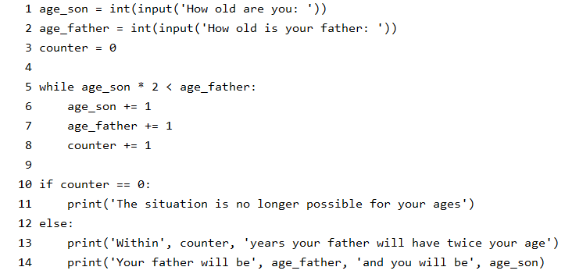

**Exercise 11**

Write a program that cancels the numbering of the previous exercise. Use the text-file with the numbered lines as input and create a py-file without numbering.

**Exercise 12**

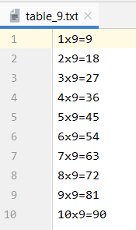Write a program that generates a random number between 1 and 10 and then places the multiplication table of that number line by line in a file.

The name of the file must be *table_ x.txt* (replacing x with the random number).

For example: the random number is 9.

**Exercise 13**

For this exercise you use *hamlet.txt.*

1. Write a program to create a new text file *hamlet2.txt* in which there is just 1 space after each punctuation mark (comma or dot or ...), so even if there would be more spaces in the input file.
2. Write a program that reads the content of *hamlet2.txt* line by line (so do not use a list) and writes them into a new file *hamlet3.txt* but removes all vowels. Show on the screen how many characters you have read and how many characters you have written.

Write a function ***remove_vowels*** that removes all vowels from a string and returns the ‘cleared’ string.

**hamlet3.txt**

